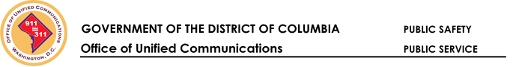

Public safety bi-directional Amplifier service Validation

Site information

Site Code:

Date:

Building Address:

Building Point of Contact Name

Building Point of Contact Email

Building Point of Contact Phone

Comments

Plan for Improvement If Applicable

Validation Results
PASS FAIL

Signatures
By signing this form, you confirm that the Bi-Directional Amplifier (BDA) providing coverage for the District of Columbia Public Safety frequencies in that building provides satisfactory coverage and quality of service.
Fire and Emergency Medical Services Representative’s Name (PRINT)

Fire and Emergency Medical Services Representative’s Signature | Date
Office of Unified Communications Representative’s Name (PRINT)
Office of Unified Communications Representative’s Signature | Date

