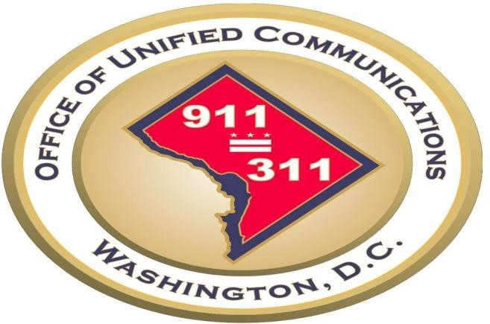

District of Columbia’s Public
Safety In-Building Radio Systems
Approved Testing Vendors
As Of 2022, August 15th

Version 3.0

GOVERNMENT OF THE DISTRICT OF COLUMBIA
Office of Unified Communications, Washington, DC

OUC Approved Vendors

Below the contact information for the vendors approved to perform acceptance testing and annual testing on behalf of the OUC:

Wireless Communications | Michael Dausener | 202-437-7535 | mdausener@wireless-inc.com
 | Mike Blincoe | 410-980-8663 | mblincoe@wireless-inc.com
Motorola Solutions | Mathew Suit | 443-524-4507 | matthew.suit@motorolasolutions.com
 | Scott Cameron | 443-754-0454 | scott.cameron@motorolasolutions.com
Communications Electronics | Jason Jacobs | 888-825-5234 | RFTesting@talkcei.com
Telnet-Inc | Frank Dastvan | 240-449-0277 | Frank.dastvan@telnet-inc.com

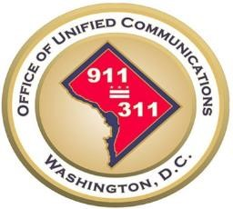

Public Safety In-Building Radio Systems: Testing Companies Approval Process Page 2

